# SNU developer log day 433

I had another really good day with development again today. It was also announced last night that school is canceled for the summer and that all classes will be online now. So I don't have to worry about going back to school and getting back into schedule anymore. Today I worked on documentation, an update to the SNU Video center, which is going to be a massive part of the site. I also did an update to the Internet Museum, I have a working format for page syntax going now, and I wanted to update it today. I also worked on a new Health Center, which will be a part of the site dedicated to health, and I also did some critical updates to SourceBase. I would do more, but I don't have as much time today, and I don't want to overwhelm myself.

The new SNU Standard template is working really well for me, it has significantly sped up page development time for new pages. On the Blue screen project, I still have gotten no feedback back from my brother-in-law, I might need to remind him about it. Today was another really good day for development, development has been going semi-strong for 3 days now. I am also doing well in some of my other projects, but I might need some time to work on 2 projects. I haven't set up a time for it yet.

So an update on Cobie, we had him up until today, but we weren't able to foster him. He was a really good dog, but we weren't the right family for him. After he started peeing all over the house, and after running off 7 times (We had to catch him 7 times, he managed to fit through the doggy door, and we had to chase after him across the neighborhood, even at midnight) we had to take him back today. As a parting present, we gave him one of our dog beds that he liked, I will miss him, but I hope he finds a family that can care for him well. He is an outside dog, but we are well-used to inside dogs.

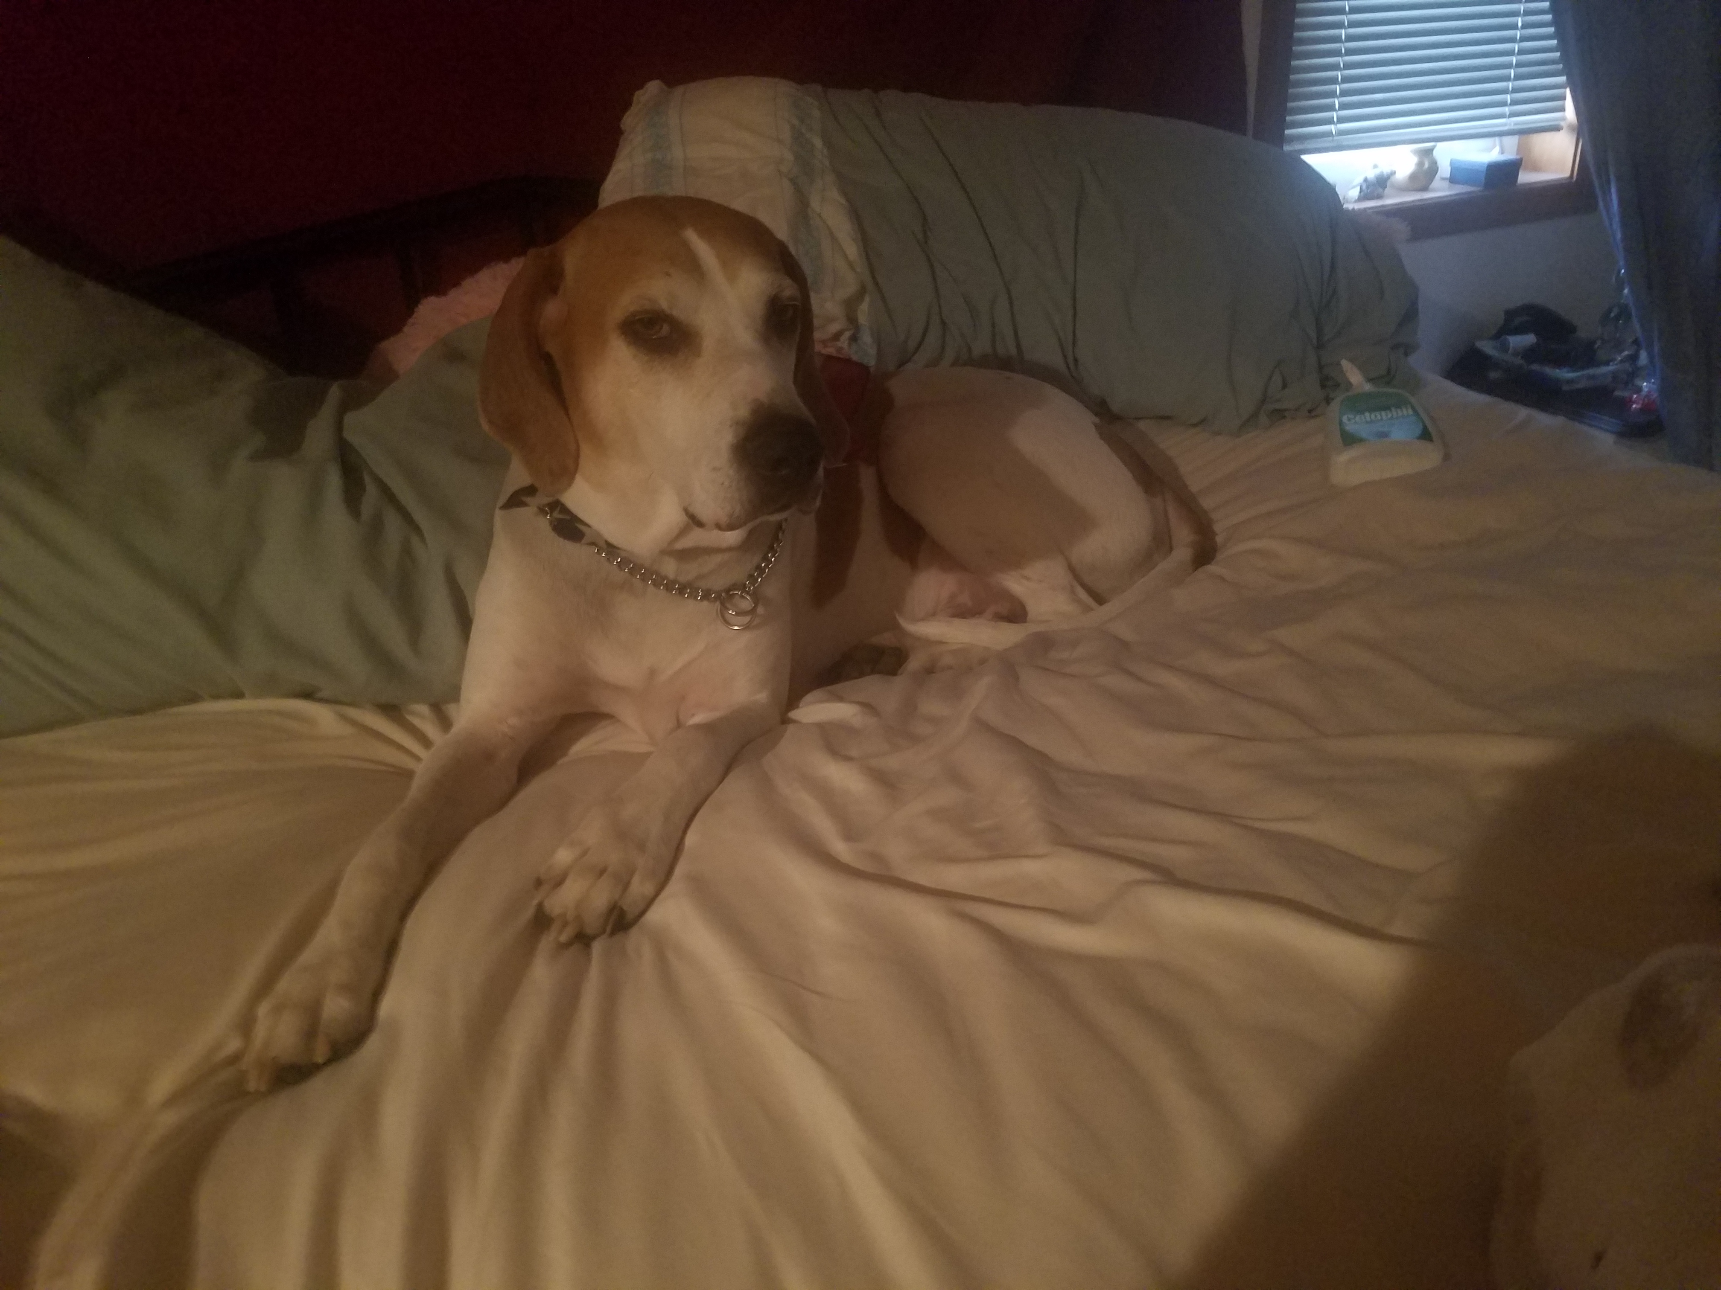

He at least had a good time with us. It was definitely better than staying at the Humane Society through all of Quarantine. Here is the best picture I have of him.

Sean Patrick Myrick on April 7th 2020